LO: Can we value each other’s opinion?
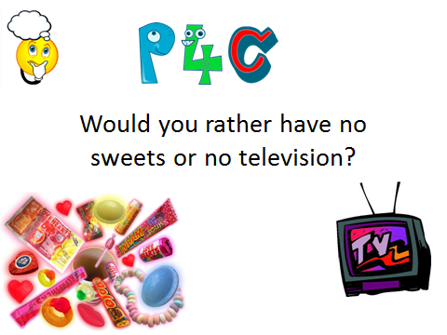

My ideas about no sweets:
I would rather have no sweets because..

My ideas about no TV:
I would rather have no TV because ..

My opinion is I would rather have no _______________ because
_________________________________________________________________

