The lion, The Witch and The Wardrobe Extract
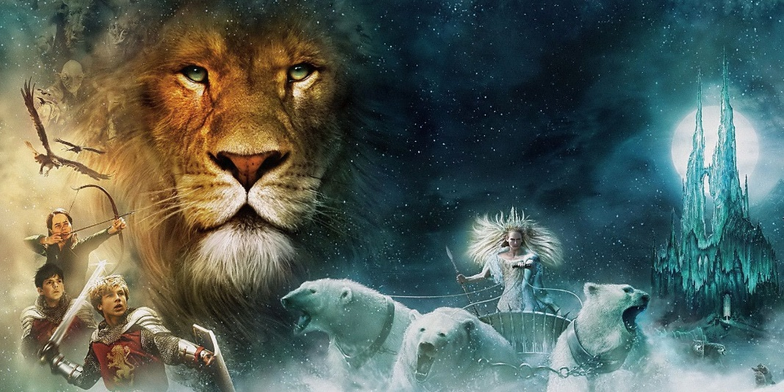
The reindeer were about the size of Shetland ponies and their hair was so white that even the snow hardly looked white compared with them; their branching horns were gilded and shone like something on fire when the sunrise caught them. On the sledge, driving the reindeer, sat a fat dwarf who would have been about three feet high if he had been standing. He was dressed in polar bear’s fur and on his head he wore a red hood with a long, gold tassel hanging down from its point; his huge beard covered his knees and served him instead of a rug. But behind him, on a much higher seat in the middle of the sledge sat a very different person- a great lady, taller than any woman that Edmund had ever seen. She also was covered in white fur up to her throat and held a long, straight, golden wand in her right hand and wore a golden crown on her head. Her face was white – not merely pale, but white like snow or paper or icing-sugar, except for her very red mouth. It was a beautiful face in other respects, but proud and cold and stern.

Questions:
- What size are the reindeer?
- Who was driving the sledge?
- What was the dwarf wearing?
- Where was the lady sat?
- What time of day do you think it is? Explain…
- The lady is described as ‘stern.’ What do you think this means?
- Why do you think the author chose to give the lady a red mouth? What do we associate the colour red with?

