Mrs Halim
Can you compare what happens in a Church and Mosque?
Place of worship | What happens in a church/mosque?
Church

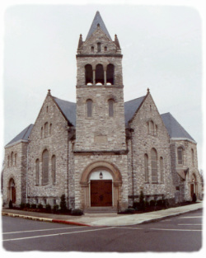

Mosque

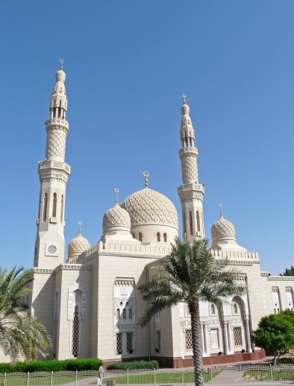

Reflection: What are the similarities between a Church and a Mosque?
________________________________________________________________
R A G

