Monday 16th November 2020
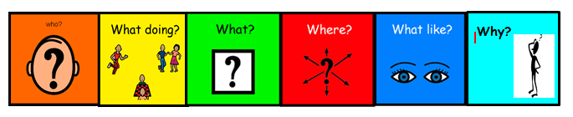
Can I use colourful semantics to describe a picture?

