Can I learn some key facts about the French Revolution?
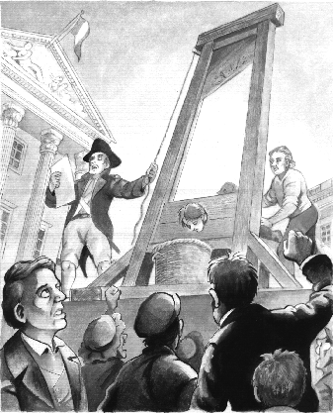
La Révolution Française

Watch this clip and circle the correct answer:
http://www.youtube.com/watch?v=cKXx7fYF8pY

- The French Revolution started in: a) 1789 b) 1889 c) 1989
- It started in: a) London b) Marseille c) Paris
- At that time the rich people were: a) happy b) hungry c) living in poverty
- The poor people were: a) happy b) hungry c) wealthy
- A peasant is: a) a rich person b) a poor farm worker c) a bird
- The poor people wanted to revolt so that:
a) the rich would become richer b) the poor would become poorer
c) people would be treated more fairly
- During the Revolution the King was:
a) King Louis 16th b) King Louis 14th c) Napoléon
- The Queen was: a) Elizabeth II b) Marie Antoinette c) Queen Louis
- The poor people did not have the right to a) work b) vote c) eat
- The King ruled France for about: a) 4 years b) 4 months c) 4 decades
- When captured the King and Queen were:
a) imprisoned b) given a fine c) executed
- During the Revolution the guillotine was used for:
a) cutting paper b) chopping off heads c) playing music
- After the Revolution the life for the peasants:
a) improved b) got worse c) stayed the same
- Who ruled France after King Louis 16?
a) King Louis 17th b) Napoléon c) Nicolas Sarkozy

