Mrs Halim
Can I understand why it is best to tell the truth?
Why is it best to tell the truth?

Draw and label what happened in ‘The Boy who cried wolf’ story.

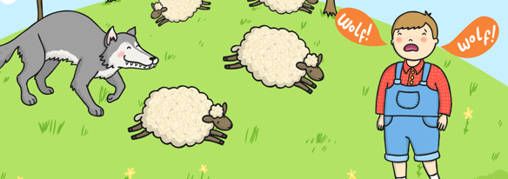

R A G

