Do some origami. You could decorate your own paper too! | Draw or paint a butterfly with exotic colours | Make your own sock puppet | Design and make a parachute to protect a boiled egg | 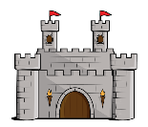  Make a castle using an empty box | Make some cornflake or rice crispy cakes
Make a papier-mâché sculpture | Design a mask for yourself – it could be an animal, warrior or something else! | 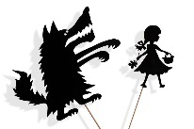  Make some shadow puppets and put on a show | Use spaghetti or toothpicks and marshmallows to build 3D shapes | Make an Easter egg hunt using real or paper eggs | Go for a walk and take some photographs
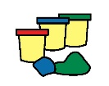  Make some playdough or clay and build an animal | 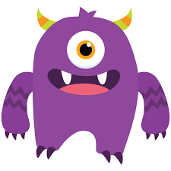  Make your own monster bookmark | Make a rocket using recycled card or plastics | 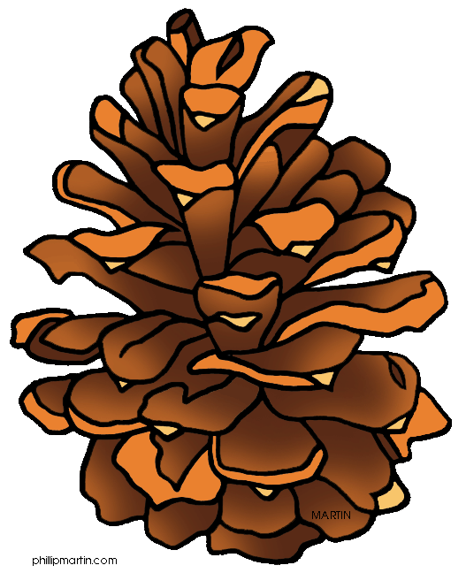  Collect some nature things make an Andy Goldsworthy picture or collage | How many times can you throw and catch a ball with a family member without stopping? | Video call a family member
Make a den in your house or garden using fabric, cushions etc. | Read a joke or fact book on myOn | 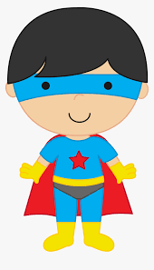  Design your own superhero with superpowers | Make a friendship bracelet out of thread, beads or wool | Design an exercise circuit in your garden or house for your family to complete | Make musical instruments out of things you find in your house
Join in with a BBC Supermovers video | Make your own board game | Design a new Easter egg and make a poster advertising it | Make a collage of your favourite things using magazines or drawings | Do an Oti Mabuse dance class on YouTube | Walk or run a daily mile
Paint rocks and turn them into rock pets | Create a poster showing healthy and unhealthy foods | 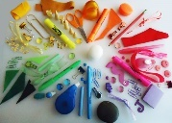  Make a colour wheel out of objects in your house | Create a bird house or bird feeder to hang in your garden | 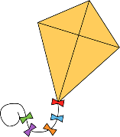  Make your own kite | Do a Joe Wicks workout on YouTube
Have a look at these ideas to keep you busy over the Easter holidays! You can continue to do My Maths, SPaG.com, Bug Club and TTRS and other learning if you choose. And don’t forget you can go for a walk, run or cycle each day!
Easter Activity Bingo

