Mrs Halim
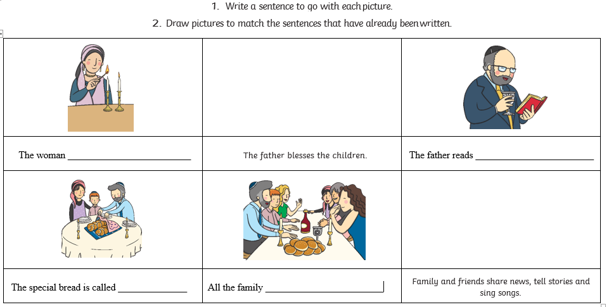
Do I know what happens during the Shabbat meal?

