Mrs Halim (Engagement lesson)
LO: What is a celebration? What do people celebrate?
________________________________________________________________________________________________________________________________________________________________________

Draw and label a celebration you enjoyed.

Reflection: A celebration is when: ________________________________________________________________________________________________________________
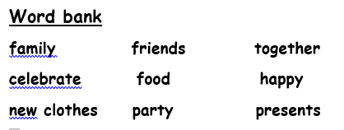
R A G

