Can I discuss the parable of the unforgiving servant?
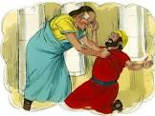

Did someone forgive the ‘unforgiving servant? If so why?____________________________________________________________________________________________________________________________
_________________________________________________________________________________
_________________________________________________________________________________

Why did the ‘unforgiving servant’ not forgive the man who owed him money?

________________________________________________________________________________________________________________________________________________________________________________________________

What would you do if someone owed you something and they couldn’t pay you back when you needed it?
________________________________________________________________________________________________________________________________________________________________________________________________________________________________________________________________

