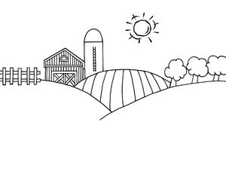

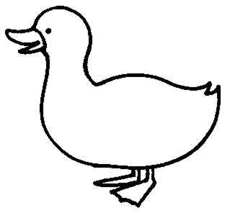

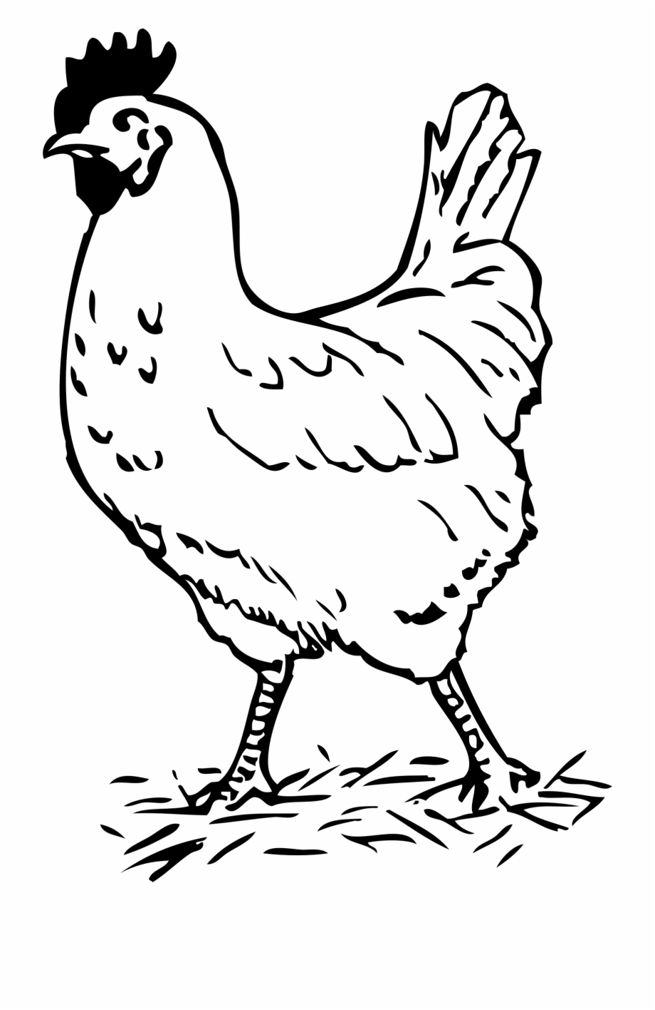



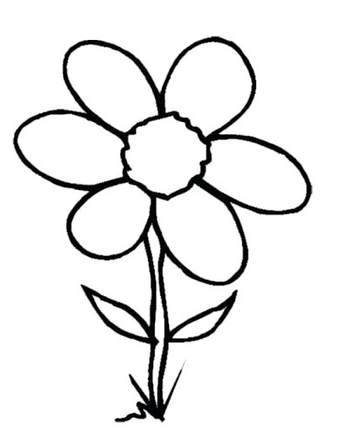







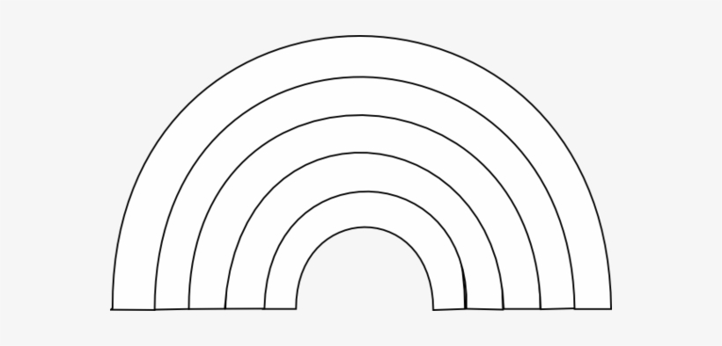

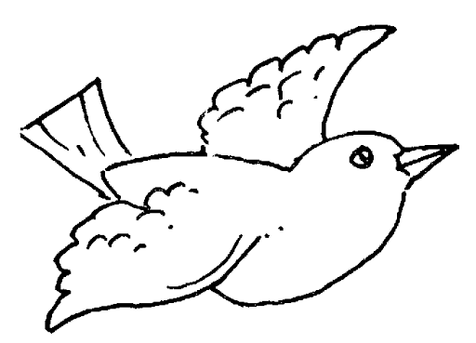

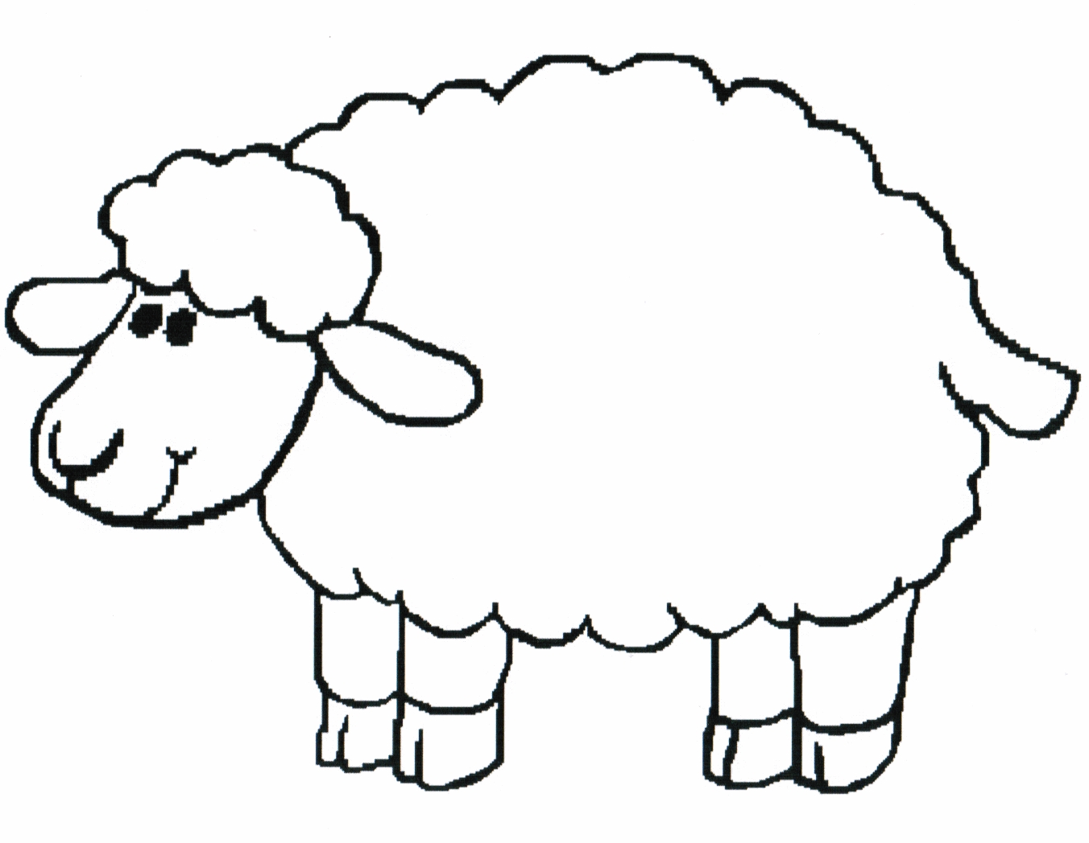

1 ICW Point to the.. 2 ICW colour the cow’s tail 3 ICW colour the big cow purple 4 ICW colour the small flower’s leaves green

cow /sheep/horse colour the fence brown colour the small sheep red colour the big cloud grey and blue

duck/bird/hen colour the horse’s ears colour the bird’s wings blue colour the shed’s door and window red

cloud /sun/rainbow colour the sun yellow colour the hen’s beak pink colour the rainbow red, orange and blue

shed/house/fence colour the field green colour the second tree orange colour the big hen’s legs orange

tree/flower/field colour the sheep’s nose colour the third flower yellow colour the small duck’s body green



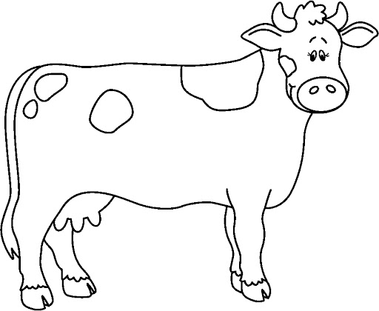





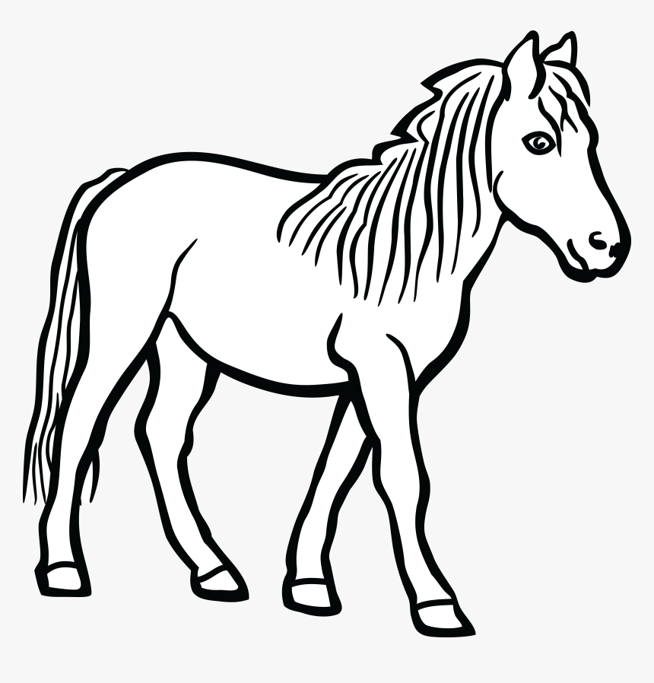



Name: ___________________________________________________ Date: _____________________________________

LO: To understand and complete a 1/2/3/4 Information Carrying Word Instruction.