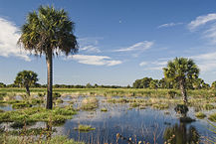
The Everglades
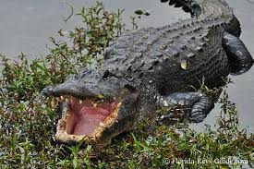
The Everglades is a unique Florida wetland that covers over 750 square miles. A wetland is an area of land that is covered in shallow water with really wet soil. Throughout a wetland you will find swamps and marshes that are full of shrubs, grassy plants, and a variety of animals such as crocodiles, alligators, flamingos, panthers and snakes. The Everglades are located in the southern part of Florida near the city of Miami. The Everglades is a National Park.

Climate
The Everglades have a subtropical climate, which means it has hot, humid summers and cool, mild winters. There are two seasons in this region, the rainy season and the dry season. During the rainy season, the Everglades can get up to 60 inches of rain. That is almost double the average of other areas in the United States.

