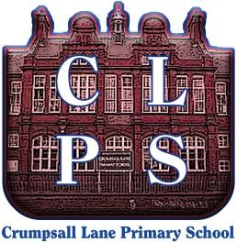
North Manchester Primary Federation
Crumpsall Lane Primary School
Crumpsall Lane, Manchester, M8 5SR
Tel: 0161 740 3741
Executive Headteacher: Mr. P. Hughes
Head of School: Mrs. J. Fairclough
Assistant Headteacher: Mrs. E. Williams

5th July 2021

Dear parents/carers,

As you may already know, there are increased covid rates in Manchester due to the Delta variant. The age group with the highest increase of confirmed cases is young people aged between 11 and 24. The areas of Cheetham and Crumpsall have both been identified as Enhanced Response Areas.

If you have any of the following three main symptoms, you must book a PCR test as soon as possible:
• a high temperature
• a new, continuous cough
• a loss or change to your sense of smell or taste
These tests are booked online and administered at a local test centre. The person with symptoms and members of the household must self-isolate until results are received.

If you are identified as a close contact, you should:
- Book a PCR test whilst self-isolating.
- Continue to isolate if the PCR result is negative, for the required 10-day period. The purpose of taking a test is to identify any close contacts who are also positive and a negative result for a close contact does not mean that you stop isolating.
- If your PCR result is positive. start an isolation period of 10 days from the date of the test result,
A change in guidance has been set in Manchester until 19th July. This is regarding a set of wider symptoms and PCR testing. You should get a test if you have any of the symptoms listed below:
- diarrhoea,
- a persistent headache,
- fever and chills, shortness of breath or difficulty breathing,
- fatigue, muscle or body aches,
- sore throat,
- congestion or runny nose,
- nausea or vomiting.
If you or your children have these symptoms, you should get a PCR test. You can continue to work and attend school whilst you wait for your test result if you display wider symptoms and none of the three main symptoms. If the result is positive, you will need to self-isolate immediately.
As a school we are still following strict social distancing, wearing face coverings in and around the building, operating in bubbles and ensuring hand hygiene routines are in place. We thank you for your continued support with these safety measures so that we can remain open and disruption is kept to a minimum.
I hope that this information helps you in keeping you and your families safe.
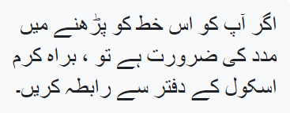
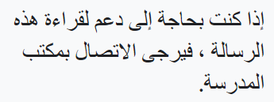
Yours sincerely
Mrs Fairclough
Head of School

Si vous avez besoin d'aide pour lire cette lettre, veuillez contacter le bureau de l'école.

